Look, say, cover, write
Look and say | write | write | write
ceremonies

sacrifice

disastrous

embarrass

opportunity

competition

recognise

convenience

immediate

exaggerate

Look, say, cover, write
Look and say | write | write | write
ceremony

disaster

opportunity

competition

immediate

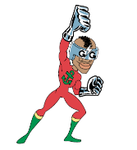Create a bubble for the following words
and then write the word in it, making sure your
letter sizes are accurate!
ceremony, disaster, opportunity, competition, immediate.

Create a bubble for the following words
and then write the word in it, making sure your
letter sizes are accurate!
ceremonies, exaggerate, disastrous, embarrass, opportunity,
competition, recognise, sacrifice, convenience, immediate.

Do a scribble spell with these words:
ceremonies, exaggerate, disastrous, embarrass, opportunity,
competition, recognise, sacrifice, convenience, immediate.

Crack the code 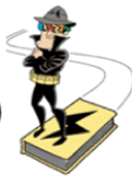
ceremonies, exaggerate, disastrous, embarrass, opportunity,
competition, recognise, sacrifice, convenience, immediate.

_ _ _r _ f _ c _
_ _ p _ _ _ u _ _ t _
_ m _ a _ _ _ _ s
_ _ _ e _ _ n _ _ _
_ _ _ _ e _ _ _ n _ _
_ _ _ p _ _ _ t _ _ _
_ _ _ e _ _ a _ _
_ _ _ a _ _ _ _ u _
_ _ a _ _ _ r _ _ _
_ _ c _ _ _ _ s _
Crack the code
ceremony, disaster, opportunity, competition, immediate.

_ _ m _ d _ a _ _
_ _ r _ m _ _ _
_ _ _ o _ t _ _ _ t _
_ _ _ p _ t _ _ _ o _
_ _ s _ s _ _ _

