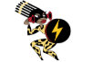 Look, say, cover, write
Look and say | write | write | write | write
Amazonian

ancient

biome
bravery

canopy

climate

deforestation

disaster

indigenous

Manaus

